Airline Sector Summary

Airline Stocks Analyzed:

UAL: United airlines

AAL: American airlines

DAL: Delta airlines

LUV: Southwest airlines

ALK: Alaska air

JBLU: JetBlue airways

RYAAY: Ryanair

ULCC: Frontier

SAVE: Spirit Airlines

SNCY: Sun country airlines

When looking at closing price data, this sector appeared to have very strongly correlated pairs, (with a few exception companies)

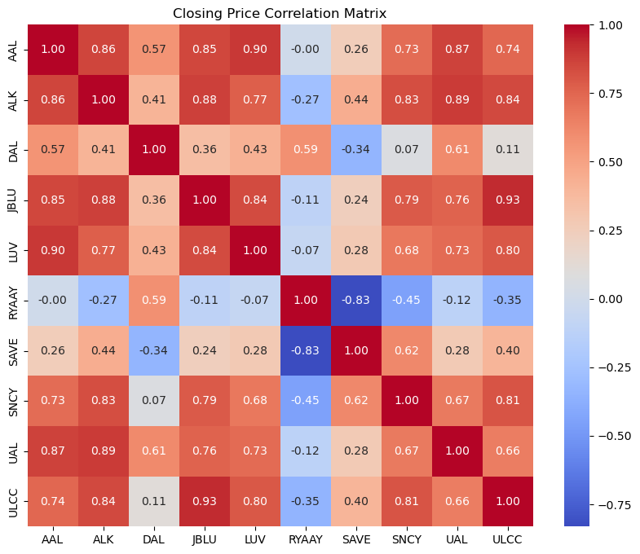

Most of our time-series models returned very little In predictions with large consistent error.

Below are results for predictions for the returns of one company: American Airlines (AAL).

They are representative of the data for other companies as well.

Model 1 Naïve model

Test Mean Absolute Error (MAE): 0.014179574718793423

Test Mean Squared Error (MSE): 0.00030387804267564415

Model 2 Rolling Average

Test Mean Absolute Error (MAE): 0.01382750332302415

Test Mean Squared Error (MSE): 0.0003069006854295606

Test Mean Absolute Percentage Error (MAPE): 98.12368216498368%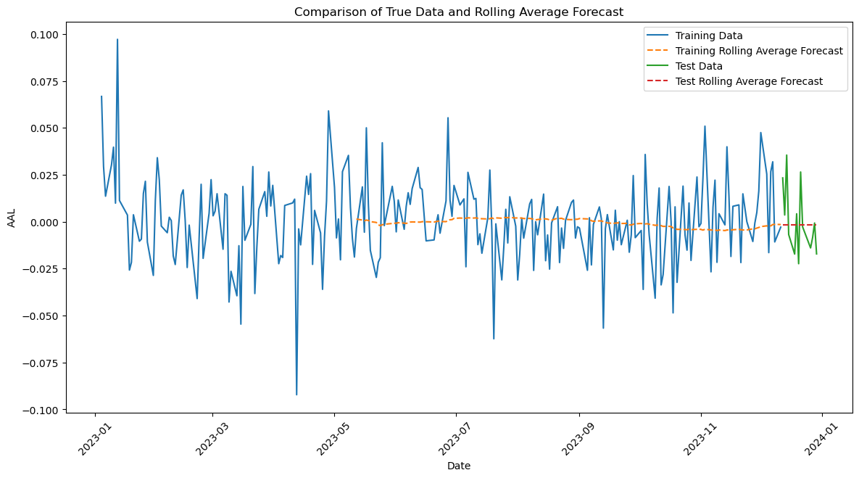

Model 3 Simple Exponential Smoothing

Test Mean Absolute Error (MAE): 0.017360450504591996

Test Mean Squared Error (MSE): 0.0003695608503006958

Test Mean Absolute Percentage Error (MAPE): 155.07442319357952%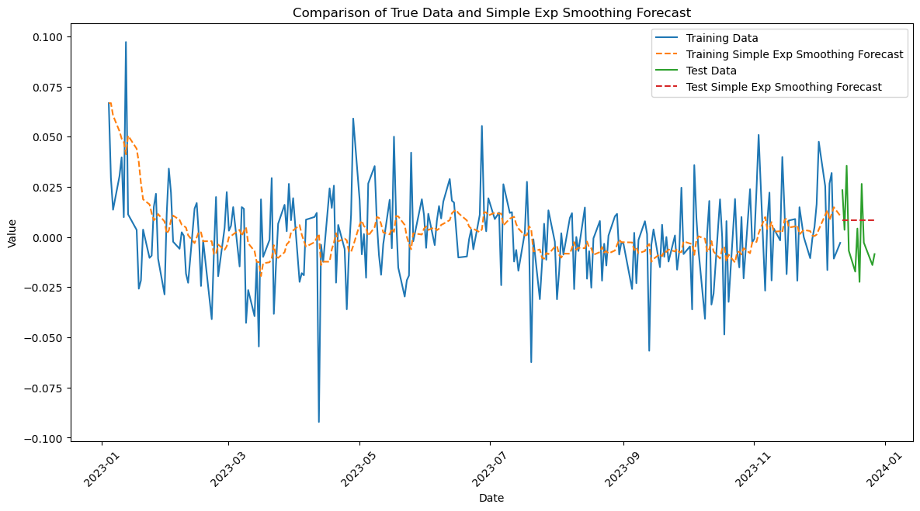

Model 4 Double Exponential Smoothing

Test Mean Absolute Error (MAE): 0.013252703057342823

Test Mean Squared Error (MSE): 0.00029903648696370593

Test Mean Absolute Percentage Error (MAPE): 93.83551226138363%

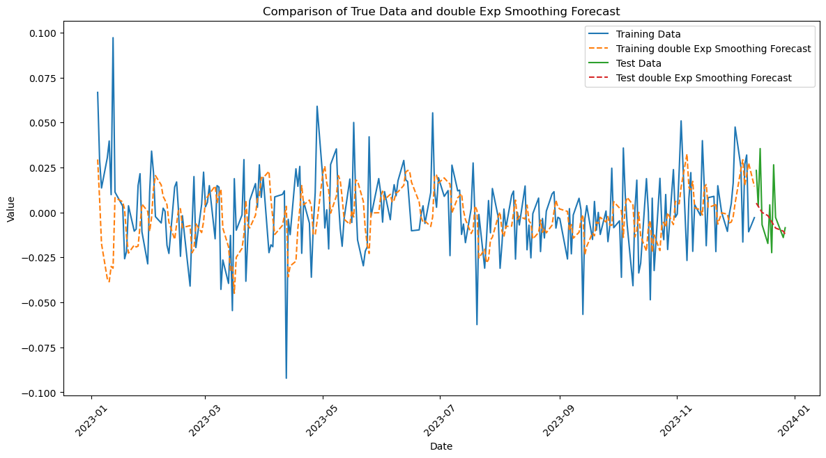

Model 5 Triple Exponential Smoothing

Test Mean Absolute Error (MAE): 0.016518459844076308

Test Mean Squared Error (MSE): 0.00034925987020049216

Test Mean Absolute Percentage Error (MAPE): 134.77028594858416%

Model 6 ARIMA

Test Mean Absolute Error (MAE): 0.01500857002058281

Test Mean Squared Error (MSE): 0.00033125804654300623

Model 7 SRIMAX

Test Mean Absolute Error (MAE): 0.014982411112079907

Test Mean Squared Error (MSE): 0.00035830408973942904

